**Placement Cell Website**

Ankesh Gaikwad, Rajshankar Khattar, Mrs. Kavita Shelke

Fr. Conceicao Rodrigues Institute of Technology

**Abstract:** Online placement system has very important role in college, its aims at providing the help to automate and simplify the registration process.

Initially all the process of the Placement Cell was done manually like collecting student data, storing it in spreadsheets, storing company’s information and criteria, selecting eligible students, acknowledging the students and generating reports, therefore we intend to introduce a system which is capable of performing tasks which will reduce the effort of the Placement Cell Coordinators to a huge extent.

The Website will have the records (personal details, academic details) of all the students who wish to appear for the placement in the current academic year. The Coordinator can generate a list of eligible students as soon as the application form by the students is filled and submitted. The students are selected on the basis of the company criteria.

The companies can be added/viewed by the coordinator. The students will receive the mail if they are eligible for a particular company. Then the students need to login to their account for confirmation and view the details of the company. The coordinator then generates the final list of interested students. If a student is selected in a particular round then the student is promoted by the coordinator for further rounds.

At the end reports are generated for a company, the number of eligible, interested, hired candidates. From the reports the coordinator will come to know about the weak points of students and where the students are lacking and hence the college can come up with different placement activities which will help the students in improving their skillsets.

**Introduction:**

The manual work makes the process slow and other problems such as inconsistency and ambiguity on operations. The increasing advantages of an automated system now are at highest position thus many manual processes are automated. Since the automated systems are demanded, educational infrastructures like colleges needed their manual systems to function on computer system. One of such system which is of major importance is placement automation for campus recruitment. This project is aimed at developing a web application for the Placement Department of the college. This system can be used as an application for the Placement Coordinator of the college to manage the student information with regards to placement. Students logging should be able to upload their information in the form of a resume. So, all the information will store the details of the students including their educational qualification, personal details, university marks and their resume’s drive link. This system helps Coordinator to access the student information with regards to placement. Coordinator can notify the students about the eligibility for a company via sending an e-mail. This system can be used as an application for college to manage the student records according placement.

**UML:**

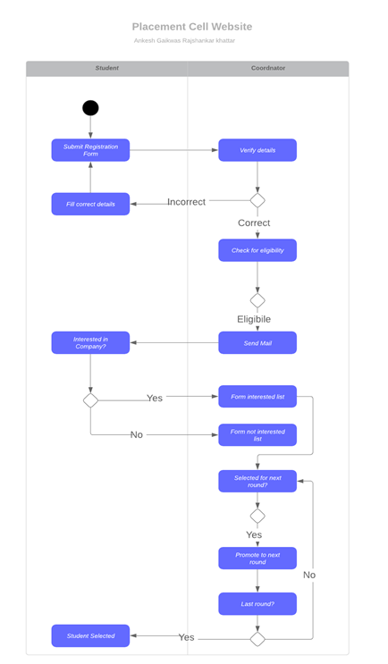

**Figure:** Swimlane activity diagram

**Module Description:**

* **Creation of Users:**

Firstly, the coordinator creates login for students for the current academic year for their respective department. Once the logins are created the students can login with the help of their Roll Number(unique) and a default password.

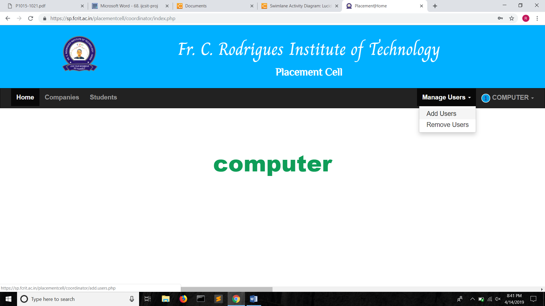

**Figure:** Creation of Users

* **Registration form**

After this, the student fills in her/his personal details, academic details and KT details and submits the registration form.

These details are recorded by the system into the database.

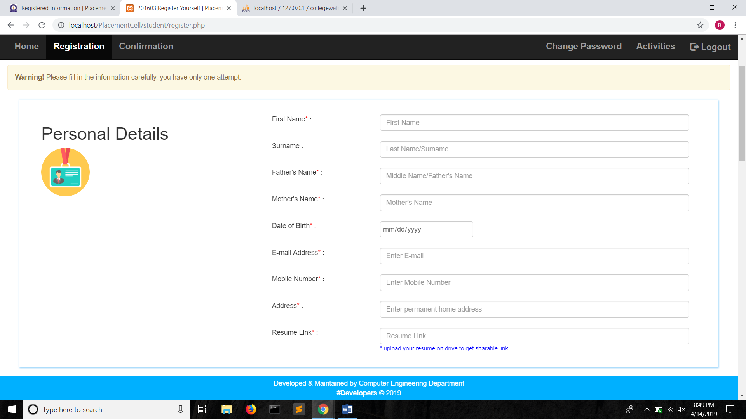

**Figure:** Registration form (1)

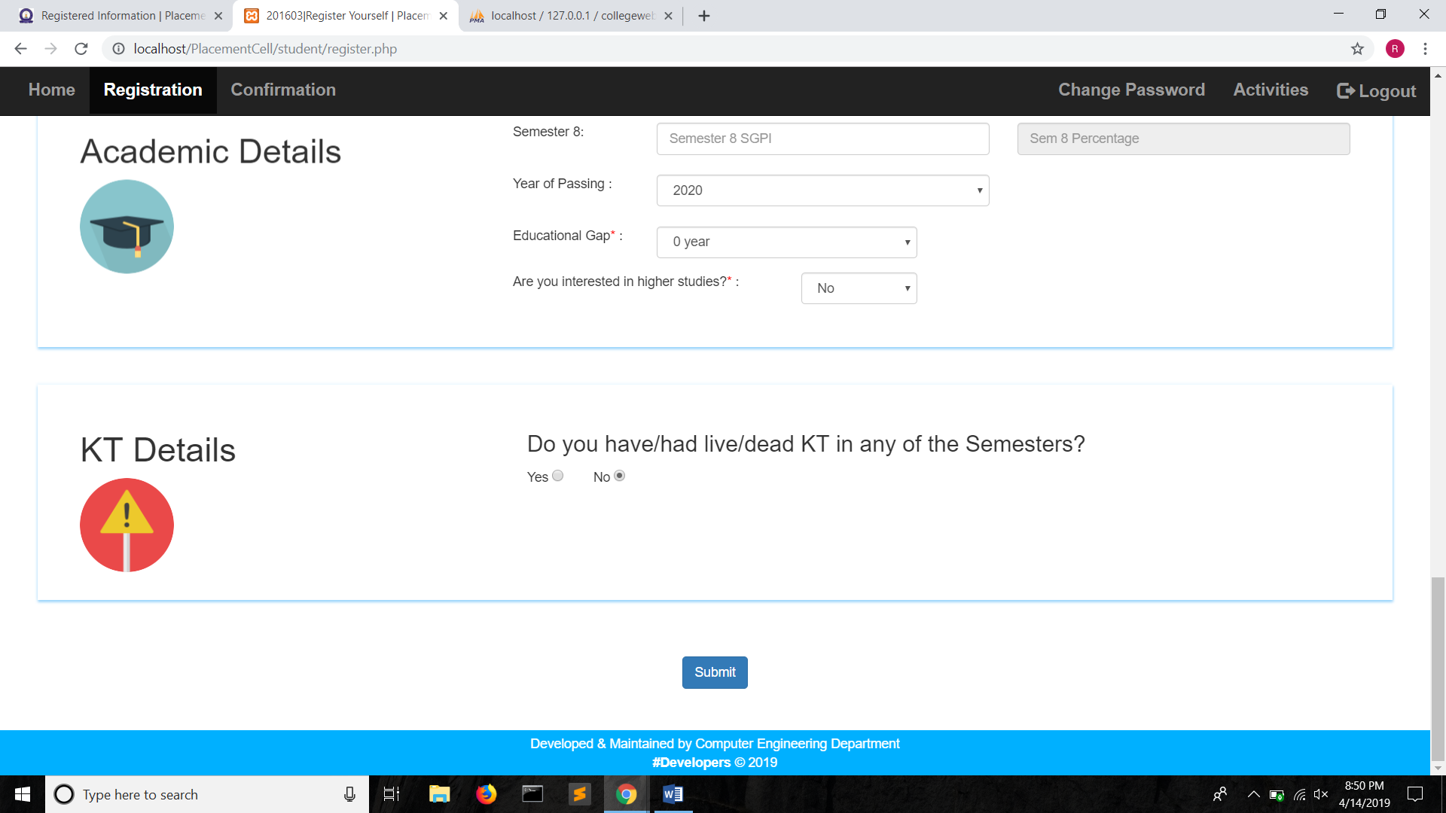

**Figure:** Registration from (2)

* **Verifying details:**

The filled details by the students are verified the coordinators. If the details are correct then the student is accepted for further placement activities. If the student has not filled in correct data then the student is acknowledged about the same and changes are made accordingly.

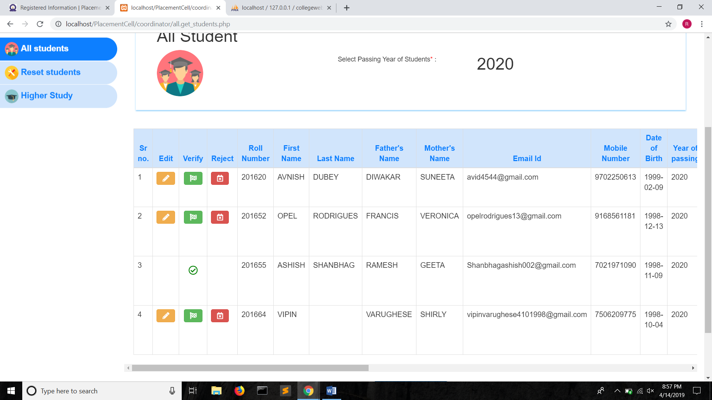

**Figure:** Verifying details

* **Resetting students:**

Once the results for a particular semester are declared, the student’s registration from is reset to update the marks of that semester. The details already verified by the coordinator cannot be modified.

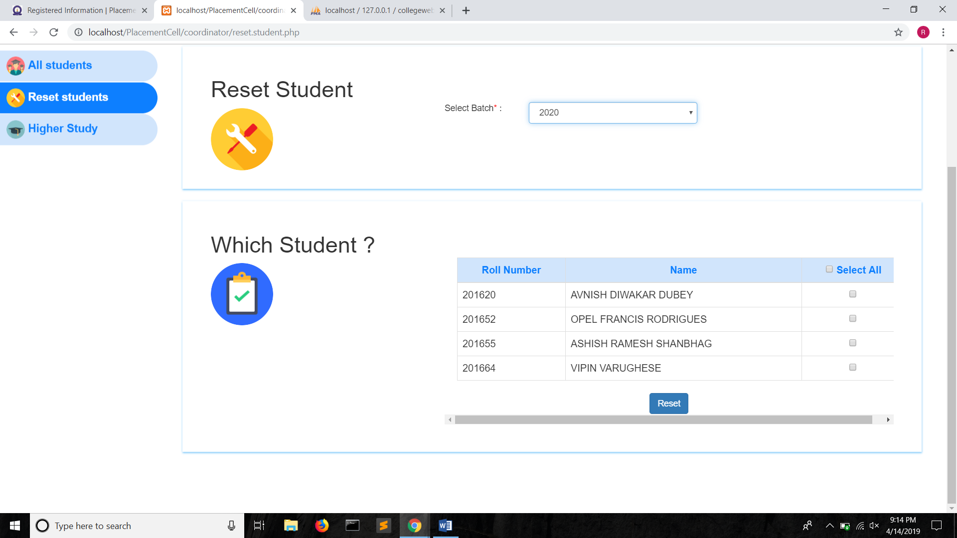

**Figure:** Reset students

* **Adding Company:**

The companies which approach the campus recruitment are added. The company details, company criteria, round information are recorded.

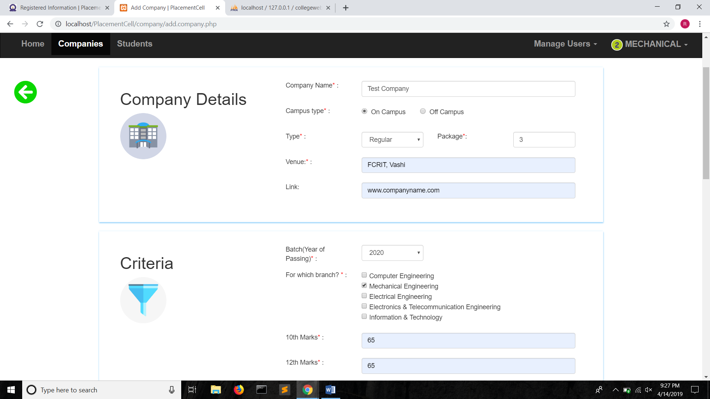

**Figure:** Adding company (1)

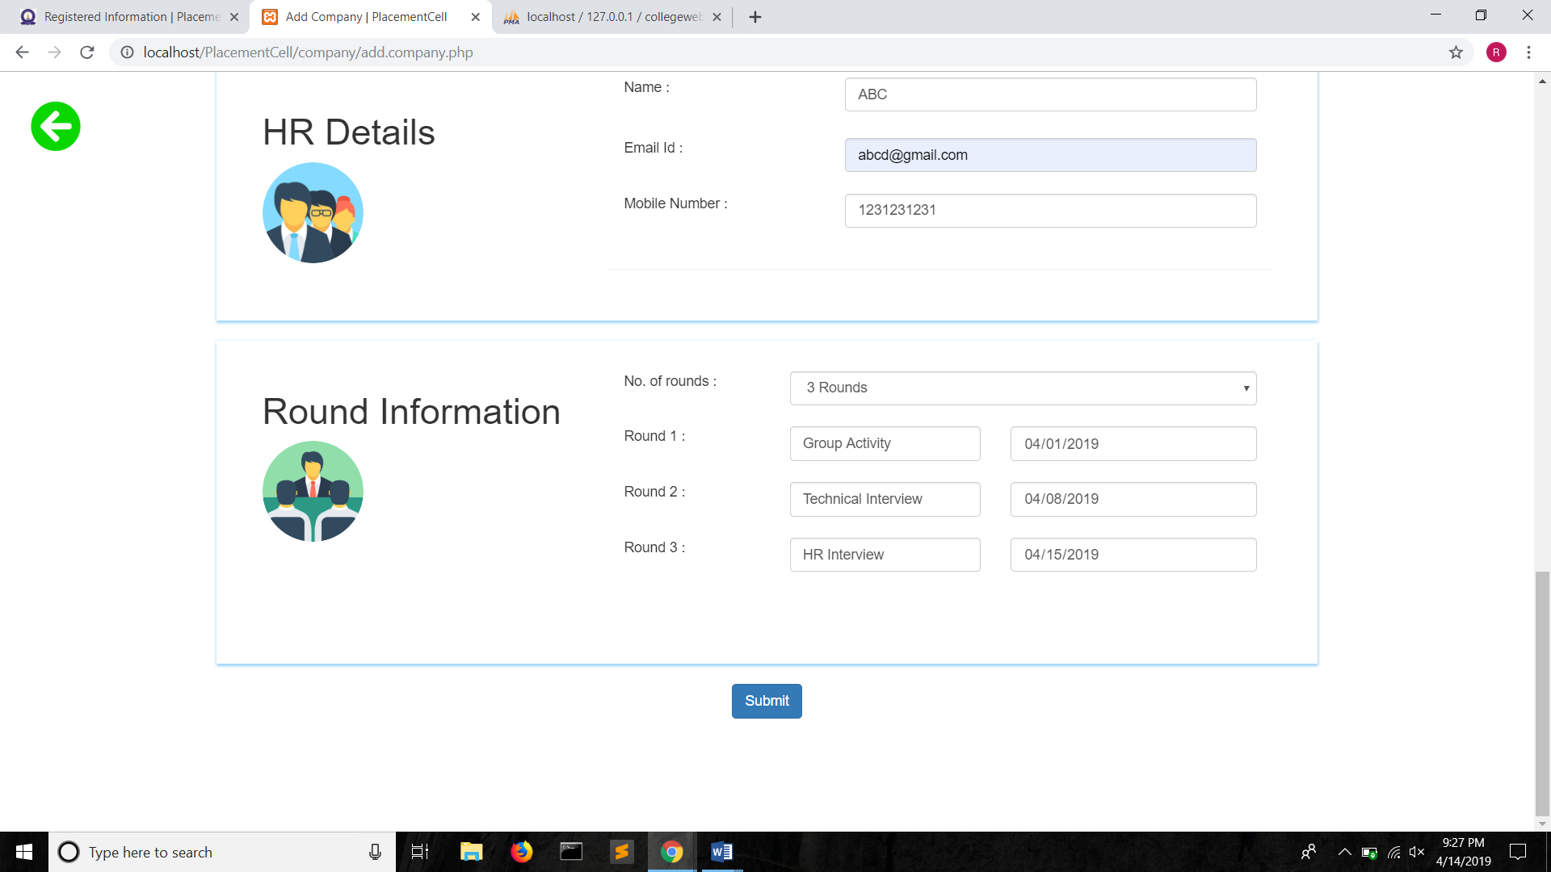

**Figure:** Adding company (2)

* **Generating Eligible students:**

Based on the academic details filled in by the students and the criteria provided by the company, the list of eligible students is created. The eligible students are acknowledged by sending them mails.

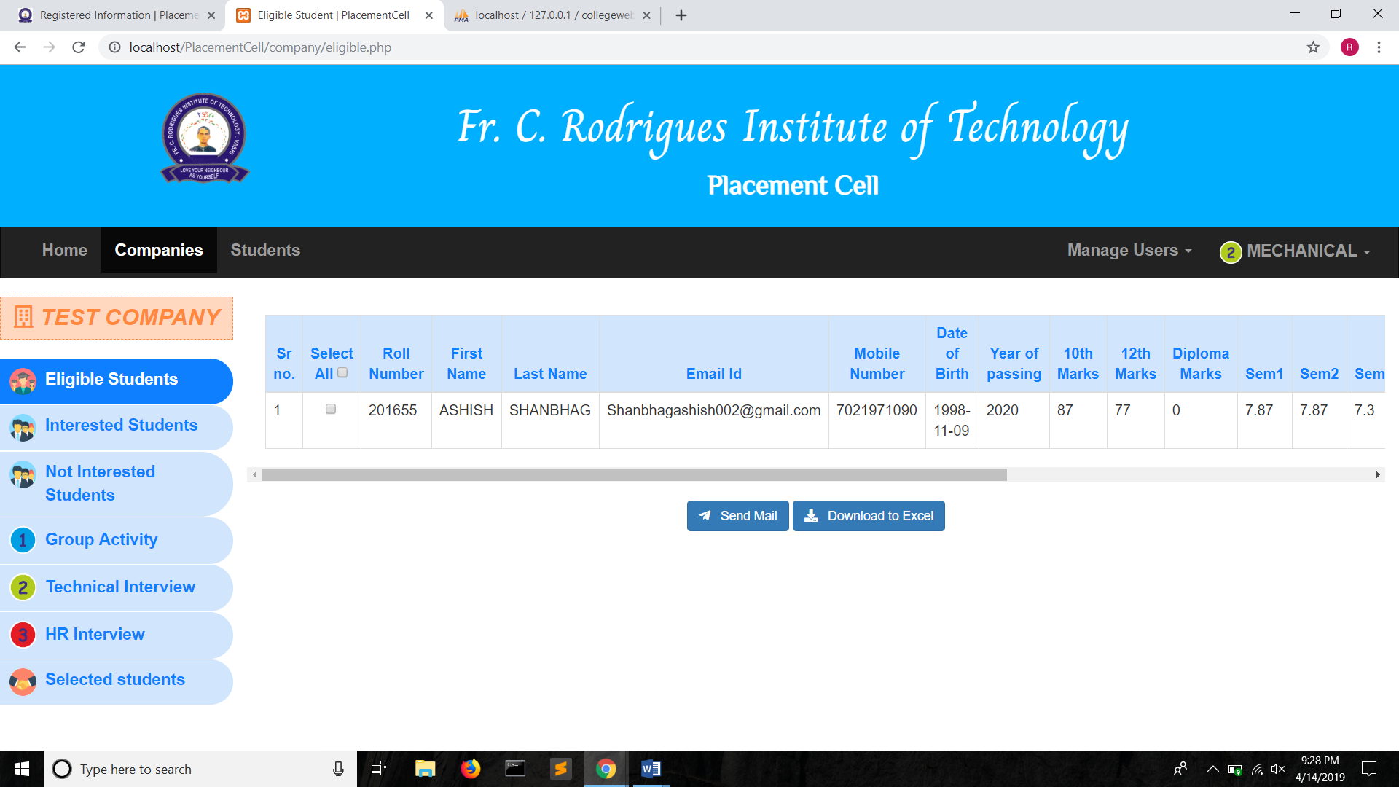

**Figure:** Eligible students

* **Interested:**

The eligible students then, can either apply for the company or can opt out of the process.

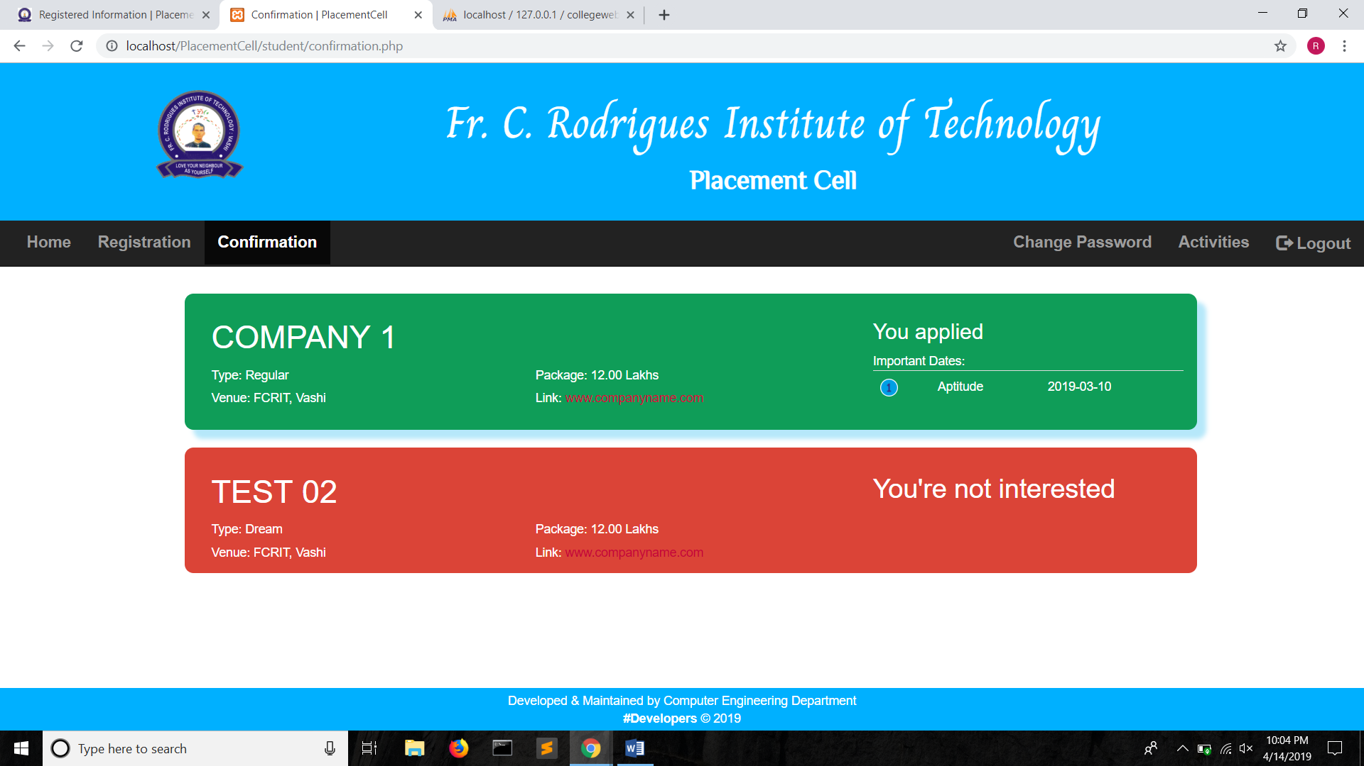

**Figure:** Confirmation

Based on the response of the student, an interested list of students is maintained and also a list of not interested students is made.

* **Promoting rounds/Selected**

If the student has cleared a particular round of the company then she/he is promoted to the next round and finally into the selected students list.

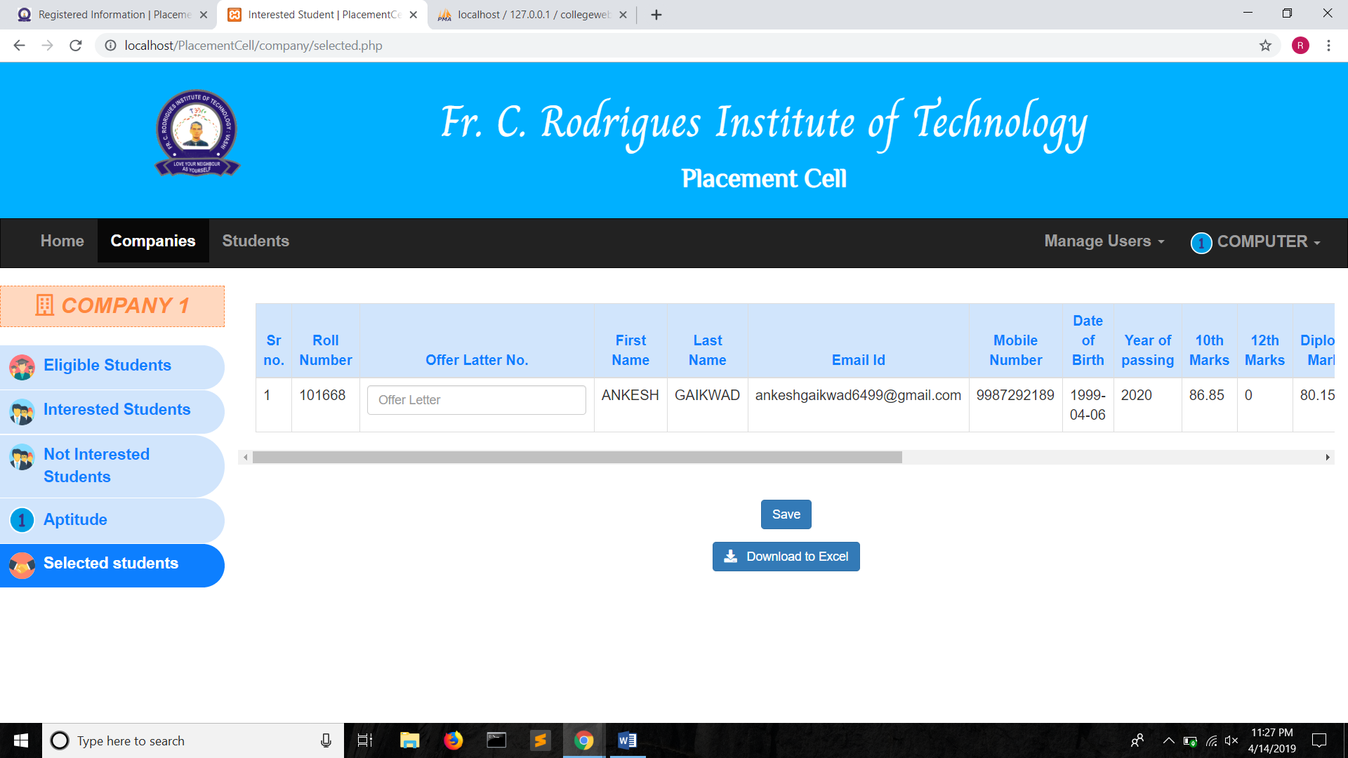

**Figure:** Selected students list

* **Other features:**
  + Logs

Each activity of the student or the coordinator is monitored with the help of maintaining logs. A log is created for logging in, logging out, update profile, change password, confirmation by coordinator, updating of profile by coordinator.

* + Hashed Passwords

The passwords are hashed in the database. If the user forgets the password then the user can click on forgot password link and an email will be sent to change the password.

* + Deletion of user logins

After the placement activities for the current academic year is finished the coordinator can delete the logins of the users thereby restricting access to them.

* + Security features

The website is free from security breaches like SQL Injection. The inputted data is server side validated for correctness. User authentication is done with the help of hashed passwords.

<http://ijcsit.com/docs/Volume%207/vol7issue2/ijcsit2016070268.pdf>

<http://data.conferenceworld.in/ICETEMR/P1015-1021.pdf>